COMSC-110 Due: June-21 at 11:59 PM Lab-3 Name:

Answer the following questions in this word document.

Copy the source code after each problem statement.

Make screen shot of the result and past it after the source code.

Chapter-4 problems



Answer:

#include <iostream>

using namespace std;

int main() {

int firstNumber, secondNumber;

cout << "Enter an integer please:" << endl;

cin >> firstNumber;

cout << "Enter a second integer please" << endl;

cin >> secondNumber;

(firstNumber < secondNumber) ? cout << "The smallest number is " << firstNumber << endl : cout << "The largest number is " << firstNumber << endl;

(firstNumber > secondNumber) ? cout << "The smallest number is " << secondNumber << endl : cout << "The largest number is " << secondNumber << endl;

return 0;

}

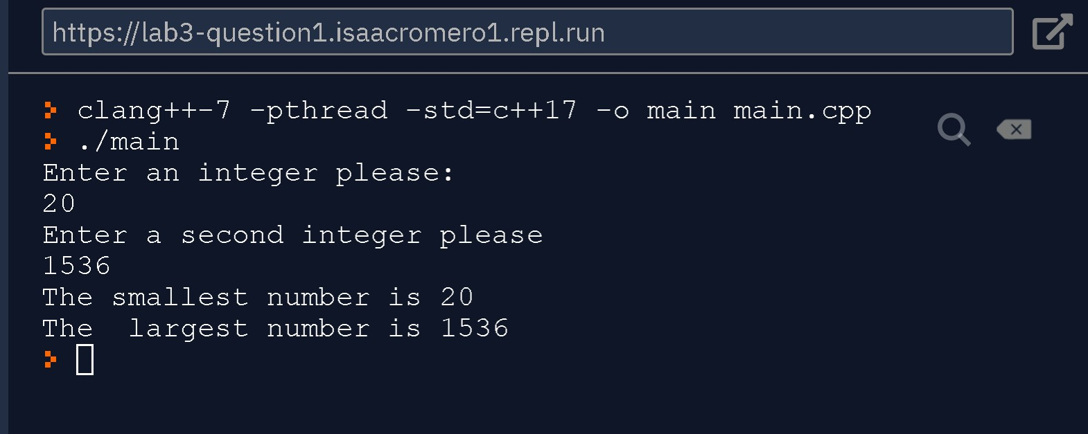

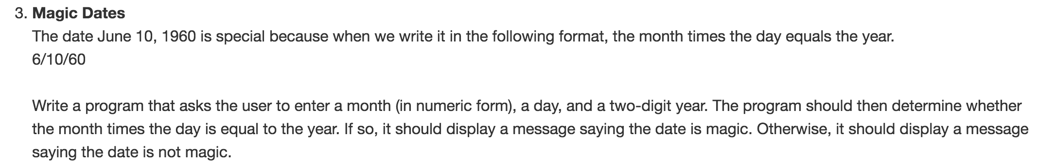

Answer:

#include <iostream>

using namespace std;

int main() {

int month;

int day;

int year;

cout << "Enter a number for a month ( 1- January, 2-February, etc)" << endl;

cin >> month;

cout << "Enter a day? " << endl;

cin >> day;

cout << "Enter a two digit year" << endl;

cin >> year;

(month*day == year) ? cout << "This is a magic date! :)" << endl : cout << "This is not a magic date! :( " << endl;

}

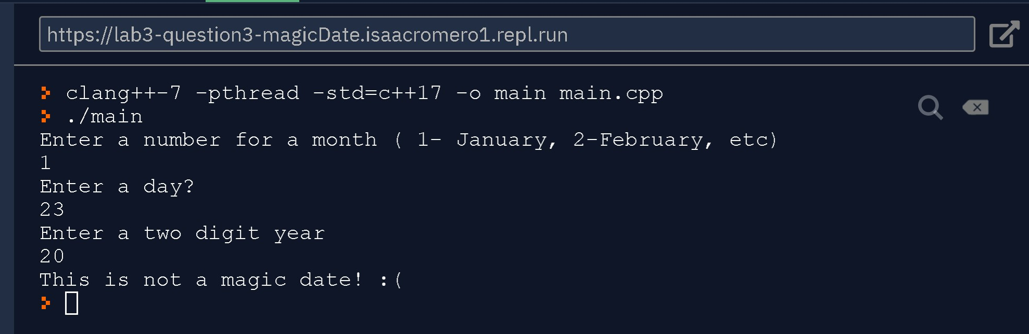

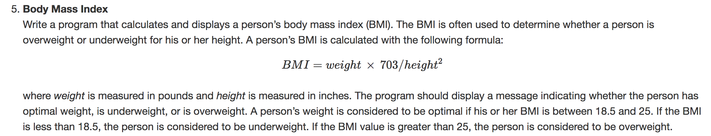

Answer:

#include <iostream>

#include <math.h>

using namespace std;

int main() {

float weight, height, BMI;

cout << "What is your weight? " << endl;

cin >> weight;

cout << "What is your height?" << endl;

cin >> height;

BMI = weight * 703 / pow(height, 2);

cout << "Your BMI is " << BMI << endl;

if ( BMI > 25) cout << "You are overweight" << endl;

else if(BMI < 18.5) cout << "You are underweigth" << endl;

else cout << "Your weight is optimal" << endl;

return 0;

}

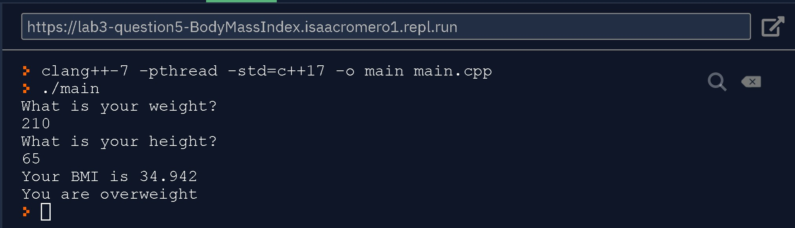

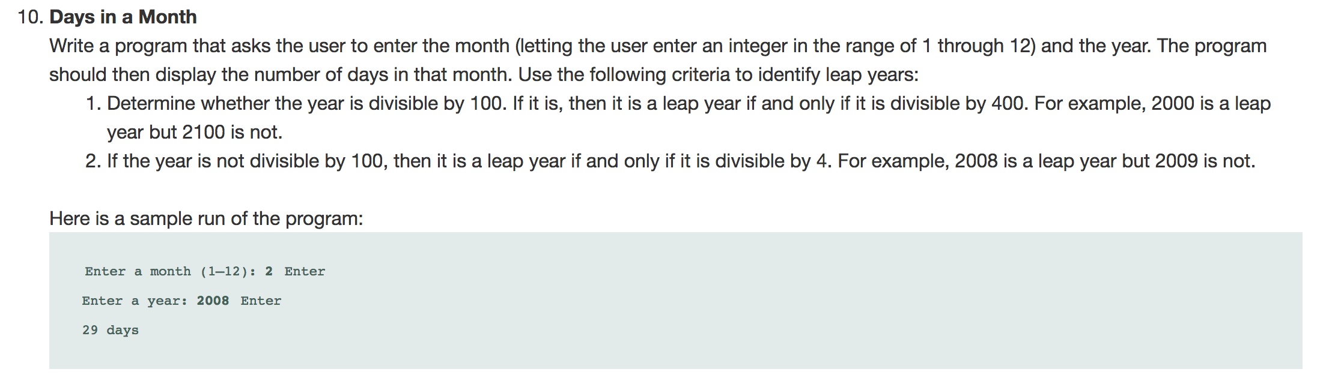

Answer:

#include <iostream>

using namespace std;

int main() {

int month, year, days;

cout << "Enter a month (1-12):" << endl; cin >> month;

cout << "Enter a year: " << endl;

cin >> year;

// 1-7 odd months have 31day exept February

// 8 -12 evens have 31day

if (month != 2) {

// if it is not February , we compute days as follow:

if (month <= 7) days=30 + month%2;

else days=30 + !(month%2);

}else{

// it is February and we need to check if it is a leap year.

if ( year% 100 == 0 ) {

if ( year % 400 == 0 ) days = 29;

else days =28;

}

else{

if ( year % 4 == 0) days = 29;

else days =28;

}

}

cout << days << " days" << endl;

}

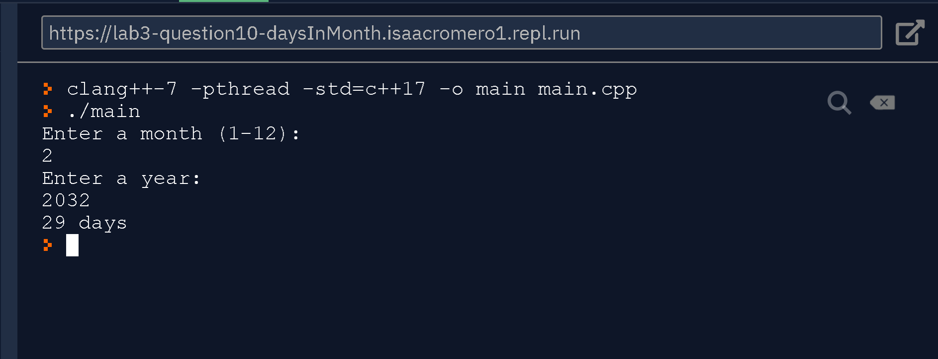

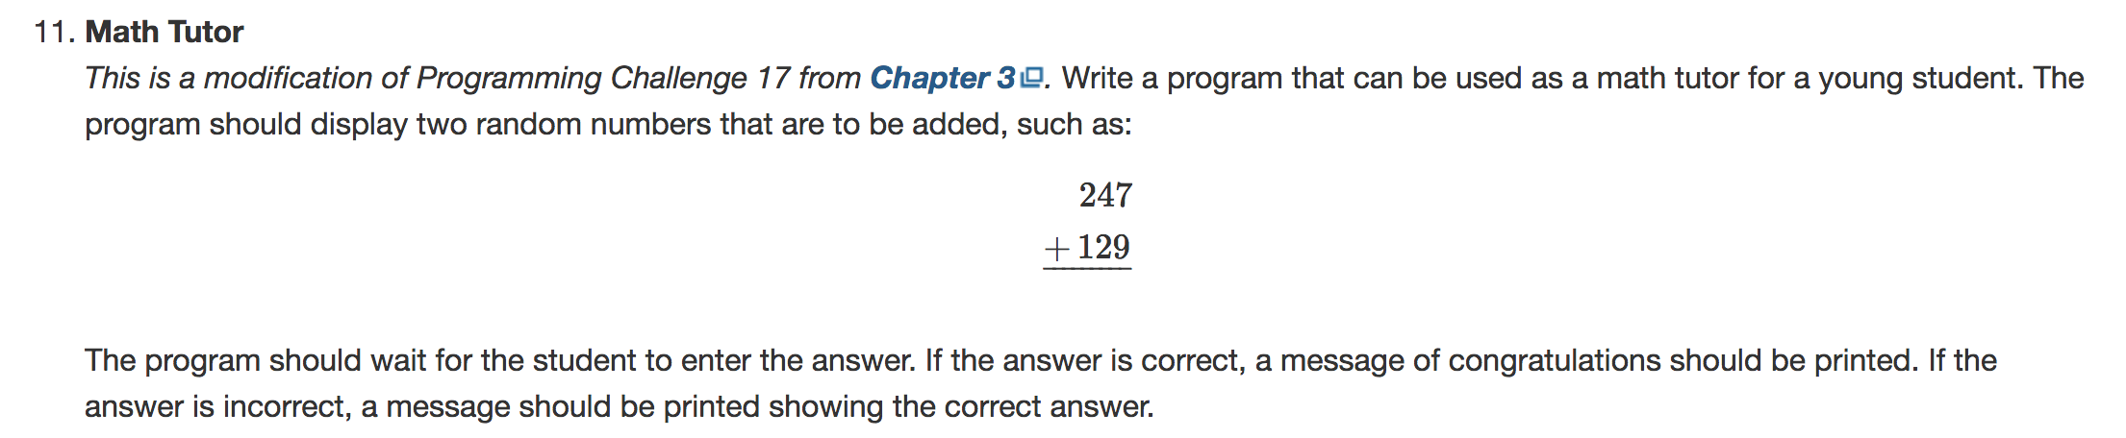

Answer:

#include <iostream>

#include <cstdlib>

using namespace std;

int main( ) {

int total;

srand (time(NULL));

int firstNumber = rand() % 999;

int secondNumber = rand() % 999;

bool next = false;

cout << "If your are done press 0."<< endl << endl;

cout << " " << firstNumber << endl;

cout << " " << secondNumber << endl;

cout << "+_______" << endl;

cin >> total;

if (total == 0) return 0;

if (total == firstNumber + secondNumber) cout << "You got it! " << endl;

else cout << "Sorry , try again" << endl;

main();

}

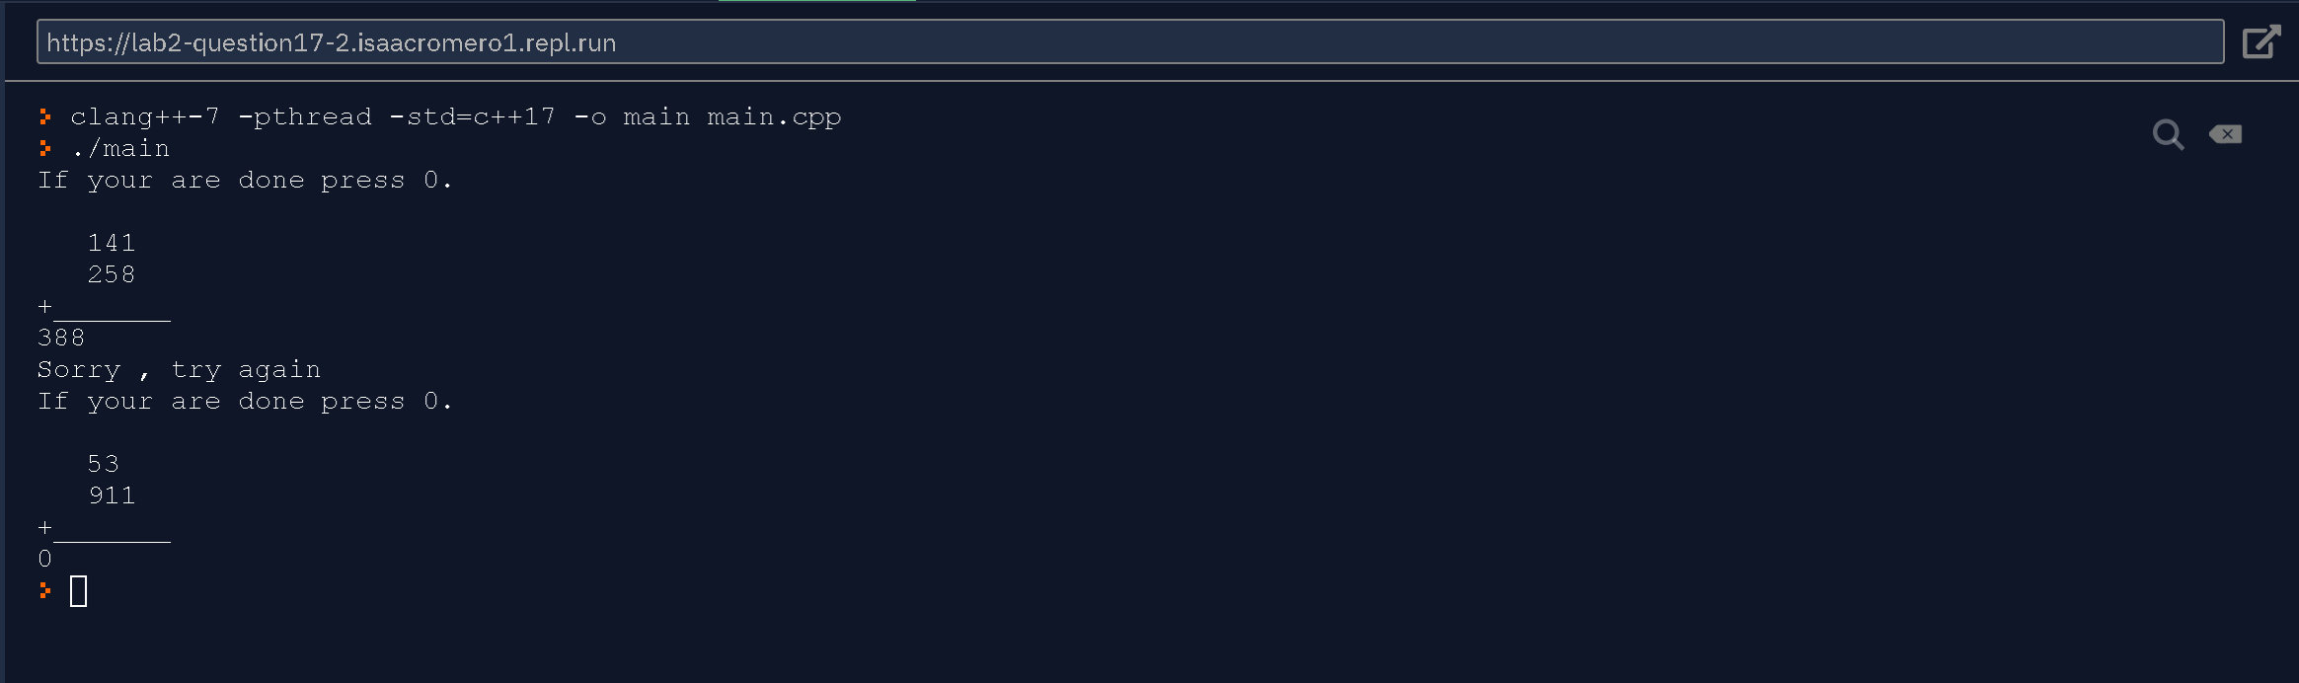

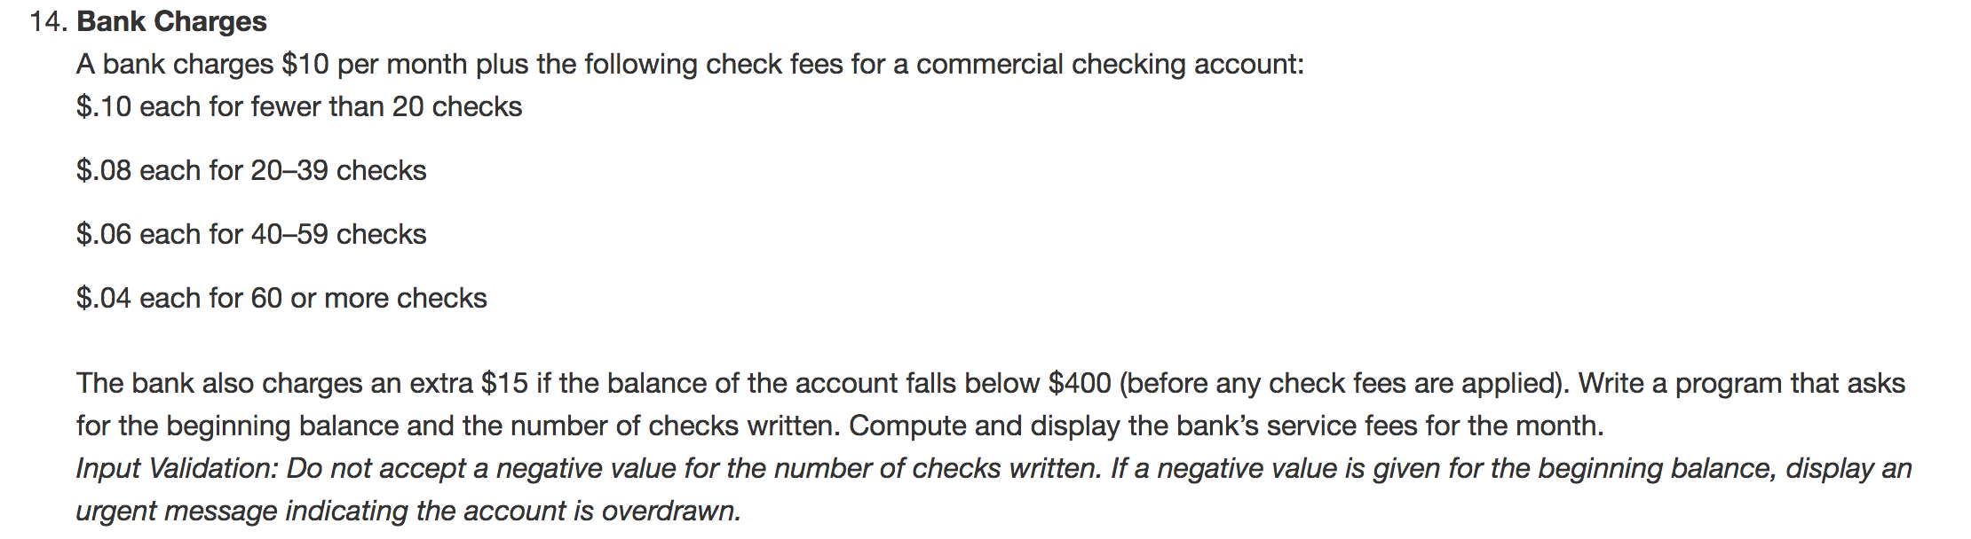

Answer:

#include <iostream>

#include <iomanip>

using namespace std;

int main() {

float balance;

int numberOfChecks = 0;

float bankFees = 0;

cout << "What is your beginning balance:" << endl;

cin >> balance;

if (balance < 0) cout << "Your account is overdrawn." << endl;

cout << "How many checks did you write? " << endl;

cin >> numberOfChecks;

while(numberOfChecks < 0) {

cout << "Number of check must not be negative. How many checks did you write? " << endl;

cin >> numberOfChecks;

}

if( numberOfChecks >= 60) bankFees+=numberOfChecks*.04;

else if (numberOfChecks < 20) bankFees+=numberOfChecks*.10;

else if( numberOfChecks >= 20 && numberOfChecks < 40) bankFees+=numberOfChecks*.08;

else bankFees=+numberOfChecks*.06;

if ( balance < 400) bankFees+= 15;

bankFees+= 10; // monthly feed

cout << setprecision(2) << fixed;

cout << "Your bank fees this month are $" << bankFees << endl;

return 0;

}

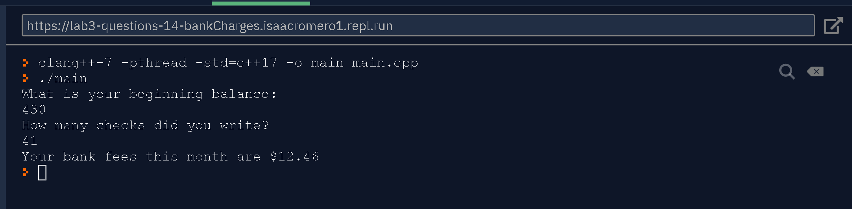

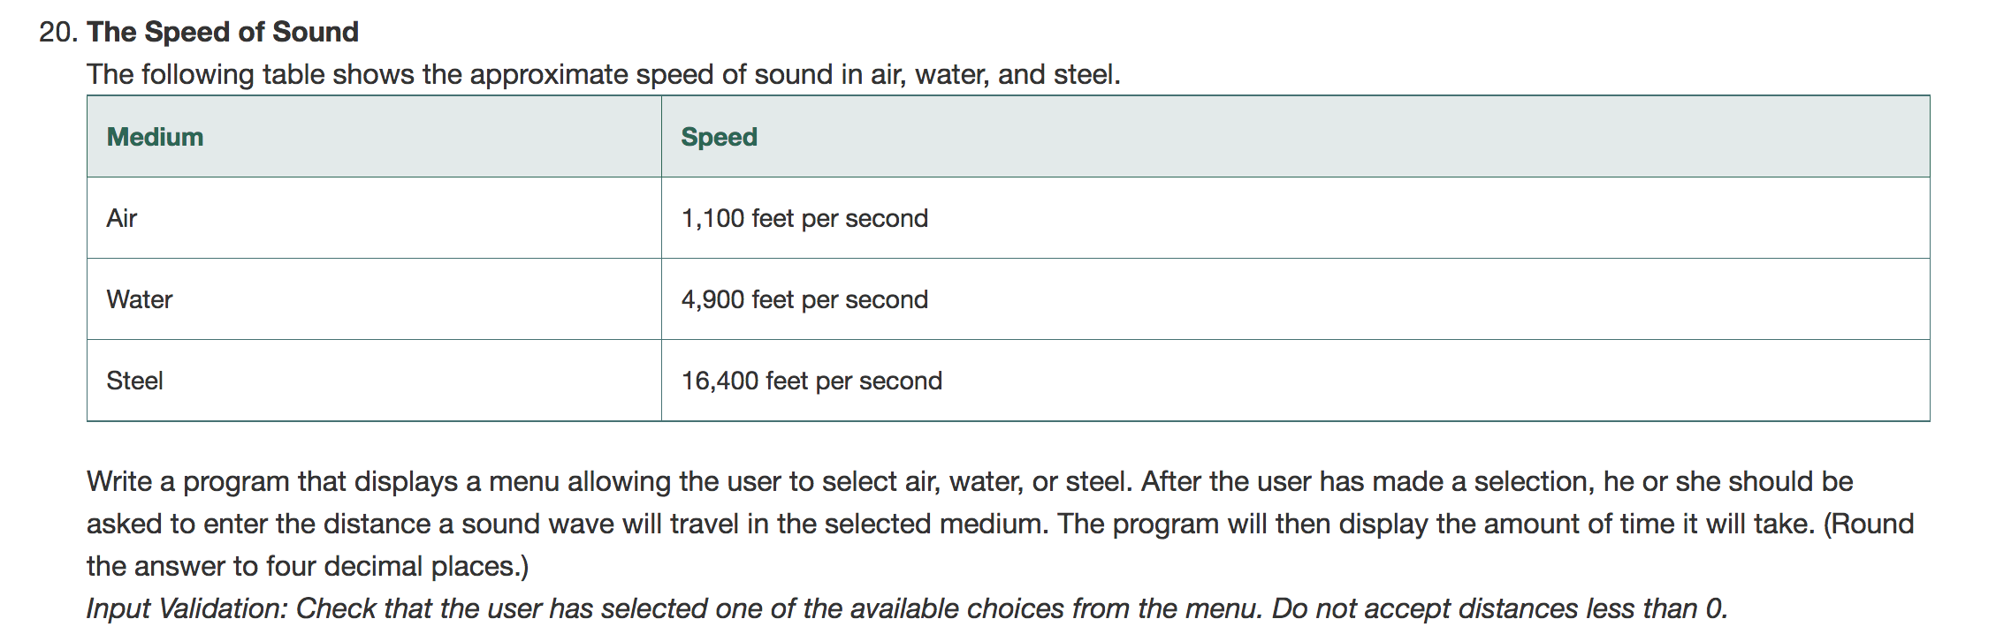

Answer:

